Section III.
Best available techniques and best environmental practices:
Guidance, principles and cross-cutting considerations

  - Guidance
      - General considerations
Article 5 of the Stockholm Convention requires Parties to develop, within two years of entry into force for them, an action plan to identify, characterize and address the release of chemicals listed in Annex C. Currently listed are polychlorinated dibenzo-p-dioxins (PCDD) and polychlorinated dibenzofurans (PCDF), as well as hexachlorobenzene (HCB) and polychlorinated biphenyls (PCB) when produced unintentionally.
The action plan, which is to be part of a Party’s national implementation plan to be developed pursuant to Article 7 of the Convention, will include strategies for meeting obligations to reduce or eliminate releases of chemicals listed in Annex C of the Stockholm Convention, and a schedule for the action plan. The plan will identify priorities for action, including for those source categories that provide the most cost-effective opportunities for release reduction or elimination. It will also include an inventory of releases of chemicals listed in Annex C.
In accordance with the implementation schedule of its action plan and taking into account the guidelines to be adopted by the Conference of the Parties, Parties are to promote and in some cases require the use of best available techniques and to promote the use of best environmental practices by identified sources of release. Parties are also to promote the development of and, where appropriate, require the use of substitute materials or processes to prevent the formation and release of chemicals listed in Annex C.
      - Policy, legal and governance issues
Just how a government promotes or requires the use of best available techniques and best environmental practices will vary from country to country, depending on its legal structure and socio-economic conditions. Possible enforcement strategies would include release estimate reporting, public information and education programmes, voluntary industry programmes, economic instruments and regulation. These issues should be address in the Party’s national action plan.
The types of measures that may be promoted or required as best available techniques to reduce or eliminate the release of Annex C chemicals can be categorized as follows: shifting to alternative processes; primary measures that prevent the formulation of chemicals listed in Annex C; and secondary measures that control and reduce the release of these chemicals.
      - Scientific and technical issues
The state of the science with regard to both the measurement of releases and levels present in the environment of chemicals listed in Annex C and what is considered “best” available techniques and “best” environmental practices will advance with time. This guidance will be continually updated to keep up with these changes.
The Convention identifies the term “best” as “most effective in achieving a high general level of protection of the environment as a whole”(see subparagraph (f) (iv) of Article 5).
      - Economic and social implications
Depending on the process that is a source of chemicals listed in Annex C, economic and social conditions in a country are a factor in determining what are “best” available techniques and “best” environmental practices. Where processes are relatively large scale, capital intensive and involve large and continuous throughputs (for example, cement kilns firing hazardous wastes, sinter plans in the iron and steel industry, fossil fuel-fired utilities) the technologies and practices used and enterprises that manage them are rather similar worldwide. In such cases, best available techniques and best environmental practices can be applied in much the same way in all countries. Where processes are relatively smaller in scale (crematoria, home heating and cooking, industrial boilers, motor vehicles) or involve management of wastes (waste incineration, open burning), the technologies and practices available may vary greatly from country to country. In these cases, determining what are best available techniques and best environmental practices will need to include an analysis of economic feasibility of the various options available. As such, “best” may mean best option that is economically feasible under the socio-economic conditions present.
      - New versus existing sources
For new sources of chemicals within source categories that warrant the use of best available techniques, as identified in their national action plans, Parties are to focus initially on source categories identified in Part II of Annex C. Parties shall phase in requirements for best available techniques for new sources in the categories in Part II of Annex C as soon as practicable, but no later than four years after entry into force of the Convention for the Party. For source categories, identified in the action plans as warranting the use of best available techniques, best available techniques are to be promoted. The use of best available techniques and best environmental practices are to be promoted for those new sources that do not warrant action in a Party’s action plan.
The use of best available techniques and best environmental practices for new sources ensures that releases of chemicals listed in Annex C are minimized to the greatest extent possible. It also allows such techniques and practices to be considered in the design and operation of the facility at a stage when they can be incorporated cost-effectively. Given the range of industrial and other activities involved, national sustainable development strategy should take into account the need to ensure that the investments into the national economy comply with this guidance and guidelines.
The use of best available techniques and best environmental practices for existing sources identified in a Party’s national action plan are to be promoted in accordance with the Party’s action plan.
Addressing existing sources is a good opportunity for a Party to reduce overall releases. In considering priority existing sources identified in its national action plan, a Party will need to consider measures to encourage necessary changes to the process or management practices that could lead to eventual attainment of best available techniques and best environmental practices. Such modifications could be phased in over time and could be part of plans to modernize a facility.

  - General principles
When applying these guidelines and guidance to sources of chemicals listed in Annex C of the Stockholm Convention, Parties may find it useful to consider some general environmental management principles and approaches that may be supportive of the Convention. The following is indicative of some of these general environmental management principles and approaches.
1. Sustainable development. “Development that meets the needs of the present without compromising the ability of future generations to meet their own needs.”
2. Sustainable consumption. “The use of services and related products which respond to basic needs and bring a better quality of life while minimizing the use of natural resources and toxic materials as well as the emissions of waste and pollutants over the life cycle of the service or product so as not to jeopardize the needs of future generations.”
3. Development and implementation of environmental management systems. “A structured approach for determining, implementing and reviewing environmental policy through the use of a system which includes organizational structure, responsibilities, practices, procedures, processes and resources.”
4. Precautionary approach. “In order to protect the environment, the precautionary approach shall be widely applied by States according to their capabilities. Where there are threats of serious or irreversible damage, lack of full scientific certainty shall not be used as a reason for postponing cost-effective measures to prevent environmental degradation.”
5. Internalizing environmental costs and polluter pays. “National authorities should endeavour to promote the internalization of environmental costs and the use of economic instruments, taking into account the approach that the polluter should, in principle, bear the cost of pollution, with due regard to the public interest and without distorting international trade and investment.”
6. Pollution prevention. “The use of processes, practices, materials, products or energy that avoid or minimize the creation of pollutants and waste, and reduce overall risk to human health or the environment.”
7. Integrated pollution prevention and control. “This principle aims to achieve integrated prevention and control of pollution arising from large-scale industrial activities. It lays down measures designed to prevent or, where that is not practicable, to reduce emissions in the air, water and land from these activities, including measures concerning waste, in order to achieve a high level of protection of the environment taken as a whole.”
8. Co-benefits of controlling other pollutants. For instance, pollution prevention and control of other contaminants may also contribute to the reduction and elimination of chemicals listed in Annex C.
9. Cleaner production. “The continuous application of an integrated preventive environmental strategy to processes, products and services to increase overall efficiency and reduce risks to humans and the environment. Cleaner production can be applied to the processes used in any industry, to products themselves and to various services provided in society.”
10. Life cycle analysis. “A system-oriented approach estimating the environmental inventories (i.e. waste generation, emissions and discharges) and energy and resource usage associated with a product, process or operation throughout all stages of the life cycle.”
11. Life cycle management. “An integrated concept for managing the total life-cycle of goods and services towards more sustainable production and consumption, building on the existing procedural and analytical environmental assessment tools and integrating economic, social and environmental aspects.”
12. Virtual elimination. “The ultimate reduction of the quantity or concentration of the toxic substance in an emission, effluent, or waste released to the environment.”

  - Cross-cutting considerations:
    - Chemicals listed in Annex C: Formation mechanisms
      - Formation of chemicals listed in Annex C: An overview
Polychlorinated dibenzo-p-dioxins (PCDD), polychlorinated dibenzofurans (PCDF), polychlorinated biphenyls (PCB) and hexachlorobenzene (HCB) are unintentionally formed in industrial-chemical processes, such as chemical manufacture, and thermal processes, such as waste incineration. PCDD/PCDF are the only by-product POPs whose mechanism of formation has been studied extensively in combustion-related processes and to a lesser extent in non-combustion-related chemical processes; even so, the mechanisms and exact formation conditions are not fully resolved.
There is far less information as to the formation of PCB and HCB, especially in combustion processes. Since there are similarities in the structure and occurrence of PCDD/PCDF, PCB and HCB, it is usually assumed that, with the exception of oxygen-containing species, those parameters and factors that favour formation of PCDD/PCDF also generate PCB and HCB.
On the other hand, in some industrial processes HCB is formed to a greater extent than PCDD/PCDF or PCBs. The guidance chapters (sections V and VI) on various types of incineration and chemical processes contain more specific process and by-product information.
      - Formation of PCDD/PCDF
  - Thermal processes
Carbon, oxygen, hydrogen and chlorine, whether in elemental, organic or inorganic form, are needed. At some point in the synthesis process, whether present in a precursor or generated by a chemical reaction, the carbon must assume an aromatic structure.
There are two main pathways by which these compounds can be synthesized: from precursors such as chlorinated phenols or de novo from carbonaceous structures in fly ash, activated carbon, soot or smaller molecule products of incomplete combustion. Under conditions of poor combustion, PCDD/PCDF can be formed in the burning process itself.
The mechanism associated with this synthesis can be homogeneous (molecules react all in the gas phase or all in the solid phase) or heterogeneous (involving reactions between gas phase molecules and surfaces).
PCDD/PCDF can also be destroyed when incinerated at sufficient temperature with adequate residence time and mixing of combustion gases and waste or fuel feed. Good combustion practices include management of the “3 Ts” – time of residence, temperature and turbulence. Use of a fast temperature quench and other known processes are necessary to prevent reformation.
Variables known to impact the thermal formation of PCDD/PCDF include:
- Technology: PCDD/PCDF formation can occur either in poor combustion or in poorly managed post-combustion chambers and air pollution control devices. Combustion techniques vary from the very simple and very poor, such as open burning, to the very complex and greatly improved, such as incineration using best available techniques;
- Temperature: PCDD/PCDF formation in the post-combustion zone or air pollution control devices has been reported to range between 200 °C and 650 °C; the range of greatest formation is generally agreed to be 200 °C–450 °C, with a maximum about 300 °C;
- Metals: Copper, iron, zinc, aluminium, chromium and manganese are known to catalyse PCDD/PCDF formation, chlorination and dechlorination;
- Sulphur and nitrogen: Sulphur and some nitrogen-containing chemicals inhibit the formation of PCDD/PCDF, but may give rise to other unintended products;
- Chlorine must be present in organic, inorganic or elemental form. Its presence in fly ash or in the elemental form in the gas phase may be especially important.
- PCB are also precursors for the formation of PCDF.
Research has shown that other variables and combinations of conditions are also important.
  - Industrial-chemical processes
As with thermal processes, carbon, hydrogen, oxygen and chlorine are needed. PCDD/PCDF formation in chemical processes is thought to be favoured by one or more of the following conditions:
- Elevated temperatures (> 150° C);
- Alkaline conditions;
- Metal catalysts;
- Ultraviolet (UV) radiation or other radical starters.
In the manufacture of chlorine-containing chemicals, the propensity for PCDD/PCDF formation has been reported as follows:
Chlorophenols > chlorobenzenes > chlorinated aliphatics > chlorinated inorganics

    - Co-benefits of best available techniques for unintentionally produced Persistent Organic Pollutants

1. General Considerations
The application of Best Available Techniques (BAT) for unintentionally produced Persistent Organic Pollutants (UPOPS) will have various co benefits. Concersely, measures to protect human health and the environment from other pollutants will also help to reduce and eliminate UPOPs.
These other pollutants include Particulate Matter, metals (such as Mercury), Nitrogen Oxides (NOx), Sulphur Dioxide (SO₂), and Volatile Organic Compounds (VOCs). Measures include flue gas processes, wastewater processes and waste processes, and monitoring and reporting.
Examples of some of these linkages and co benefits are outlined below, with further details on BAT BEP measures provided in later sections of the documents.
2. Information, Awarenes and Training

Information, awareness and training activities associated with environmental and health concerns and protection may have co benefits for the reduction of both UPOPs and other pollutants.
- Flue Gas Processes
Various flue gas processes will have co benefits for UPOPs and other pollutants.
Examples include:
  - Containment, Collection and Ventilation
These measures will reduce residential and occupational human exposure to Total Particulate Matter (TPM), Particulate Matter less than 10 microns (PM10) and Particulate Matter less than 2.5 micron (PM2,5). Pollutants associated with PMs, such as metals and metal compounds (e.g. Mercury), and gaseous pollutants such as volatile organic compounds (VOCs), may also be reduced.
  - Dust Separation Processes
Measures such as cyclones, electrostatic precipitators and fabric filters will reduce emissions of PM to the environment.
  - Scrubbing Processes
These measures will reduce emissions PM with effective mist eliminators and may reduce gaseous pollutants. Flue Gas Desulphurization (GFD) will reduce emissions of Sulphur Dioxide (SO₂).
  - Sorption Processes
Measures such as activated carbon adsorption will reduce emissions of Mercury and VOCs as applicable.
  - Catalytic Processes
Measures such as Selective Catalytic Reduction (SCR) for reduction of Nitrogen Oxides (NOx) may also reduce UPOPs if catalytic oxidation also occurs in the system. SCR may also oxidize elemental mercury which is water soluble and can be removed in FGD systems. Catalytic fabric filters may also reduce VOCs.
- Wastewater Processes
Primary wastewater treatment will remove suspended solids. Tertiary treatment such as activated carbon may remove various organics.
- Waste Processes
Measures such as waste residue solidification will reduce leaching of various pollutants to the environment
- Monitoring and Reporting
Facilities may be required to monitor, measure, estimate and report releases to the environment. These could provide public information on various pollutants and incentives for continual improvements in the environmental performance of the facilities.
Periodic comprehensive measurement scans of a wide range of pollutants including PCDD/PCDF, HCB and PCB, in addition to routine monitoring of common pollutants, could provide useful information on many potential sources of UPOPs and other pollutants.

    - Management of flue gas and other residues
      - Flue gas treatment techniques (air pollution control devices)
In principle, reduction of emissions of polychlorinated dibenzo-p-dioxins (PCDD) and polychlorinated dibenzofurans (PCDF) can be achieved with the following exhaust gas cleaning processes:
- Afterburners;
- Rapid quench systems;
- Dust separation;
- Scrubbing processes;
- Sorption process;
- Catalytic oxidation.
Air pollution control devices may be wet, dry, or semi-dry, depending on the role of water in the process. Wet and, to some extent, semi-dry air pollution control devices require additional processes to clean any waste water generated before it leaves the facility. Solid waste arising from semi-dry and dry processes (and also from wet processes after waste water treatment) has to be disposed of in an environmentally sound manner.

        - Comparison of PCDD/PCDF control techniques
The techniques which have been found to be most effective at reducing persistent organic pollutants in flue gases are those that utilize adsorbents and particulate control and those that utilize catalysts. Table 1 summarizes the collection efficiencies of selected PCDD/PCDF control techniques.
Table 1. Comparison of PCDD/PCDF control systems

Control option | PCDD/PCDF removal efficiency | Co-benefits
Cyclones | Low efficiency | Coarse dust removal
Electrostatic filters | Low efficiency | Designed for dust removal
Bag filters | Medium efficiency | Designed for dust removal
Wet scrubbers | Medium efficiency | Designed for dust or acid gas removal
Quenching and subsequent high efficiency wet scrubber | Medium to high efficiency | Simultaneous reduction of dust, aerosols, HCl, HF, heavy metals and SO₂
Afterburners | High efficiency | No residues, but quenching of flue gases required
Catalytic oxidation (SCR) | High efficiency; destruction of PCDD/PCDF and other organics | No residues, simultaneous reduction of NO_{x}
Catalytic bag filters | High efficiency | Simultaneous dust removal and NO_{x} reduction
Dry absorption in resins (carbon particles dispersed in a polymer matrix) | Depends on the amount of installed material | Selective for PCDD/PCDF; Material can be incinerated after use
Entrained flow reactor with added activated carbon or coke/lime or limestone solutions and subsequent fabric filter. | Medium to high efficiency | Simultaneous reduction of various trace pollutants; Material can be incinerated after use¹⁾
Fixed bed or circulating fluidized bed reactor, adsorption with activated carbon or open-hearth coke | High efficiency | Simultaneous reduction of various trace pollutants; Material can be incinerated after use¹⁾
- As a carbon adsorber will also adsorb mercury, care has to be taken about mercury circulation if the spent carbon is re-burnt

Costs for PCDD/PCDF control at existing facilities can be reduced by using synergies with existing air pollution control devices:
- Through activated coke injection an existing fabric filter can be extended to a flow injection reactor to reduce PCDD/PCDF. The additional costs for PCDD/PCDF reduction arise from the storage, transport, injection and disposal of the activated coke, which is used as an additional adsorbent.
- PCDD/PCDF can be destroyed with an oxidation catalyst. An existing catalyst for the selective removal of NO_{x} (nitrogen oxides) can be used for this purpose. Additional costs arise from enlarging the surface of the catalyst by adding one or two layers of catalyst to achieve PCDD/PCDF concentrations below 0.1 ng TEQ/Nm³.
In addition to the removal or destruction of PCDD/PCDF, other pollutants such as heavy metals, aerosols or other organic pollutants will be reduced.
        - Rapid quenching systems
Water quench systems are also used to bring flue gas temperatures down quickly to below the formation threshold for chemicals listed in Annex C of the Stockholm Convention. These systems and associated waste-water treatment systems must be designed to deal with the higher particulate matter loadings that will end up in the scrubber water as a consequence.
        - Afterburners
Afterburners are either separate from or integrated into the main combustion chamber for destroying unburned or partially burned carbon compounds in the exhaust gas. Depending on the actual conditions a catalyst, additional combustion air or a (natural gas-fired) burner may be required. Where appropriate, legislation would indicate minimum temperatures to achieve this destruction for a given process.
        - Dust separation
PCDD/PCDF are released with flue gases via the gas phase as well as particle bound. The fine dust fraction is enriched in particular due to its high specific surface. Since the separation of the fine dust fraction is not always achieved with electrostatic precipitators, fabric filters are more efficient for PCDD/PCDF emission reduction. Addition of sorbents may enhance the removal efficiency (Hübner et al. 2000).
            - Cyclones and multicyclones
Cyclones and multicyclones (consisting of several small cyclones) extract particulate matter from the gas stream through the use of centrifugal force. Cyclones are much less effective than devices such as electrostatic precipitators or fabric filters in controlling particulate matter releases and are rarely used alone in advanced flue gas cleaning applications.
            - Electrostatic precipitators
The electrostatic precipitator (in Europe these systems are usually referred to as electrostatic filters) is generally used to collect and control particulate matter in combustion gas by introducing a strong electrical field into the flue gas stream (Figure 1). This acts to charge the particles entrained in the combustion gases.
Large collection plates receive an opposite charge to attract and collect the particles. The efficiency of collection is a function of the electrical resistivity of the entrained particles. Electrostatic precipitators efficiently remove most particulate matter, including chemicals listed in Annex C adsorbed to particles.
Figure 1. Electrostatic precipitator principle
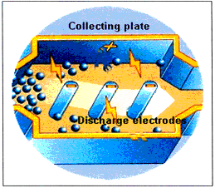
Source: European Commission 2005.
Formation of chemicals listed in Annex C can occur within the electrostatic precipitator at temperatures in the range of 200º C to about 450º C. As temperatures at the inlet to the electrostatic precipitator increase from 200° to 300º C, PCDD/PCDF concentrations have been observed to increase with increase in temperature. As the temperature increases beyond 300º C, formation rates decline.
Typical operational temperatures for electrostatic precipitators are 160-260°C. Operation at higher temperatures (e.g. above 250°C) is generally avoided as this may increase the risk of PCDD/PCDF formation.

Wet electrostatic precipitators use liquids, usually water, to wash pollutants off the collection plates. These systems operate best when the incoming gases are cooler or moist.
Condensation electrostatic precipitators use externally water-cooled bundles of plastic tubes that collect fine liquids or solids by facilitating condensation with a water quench (Figure 2).
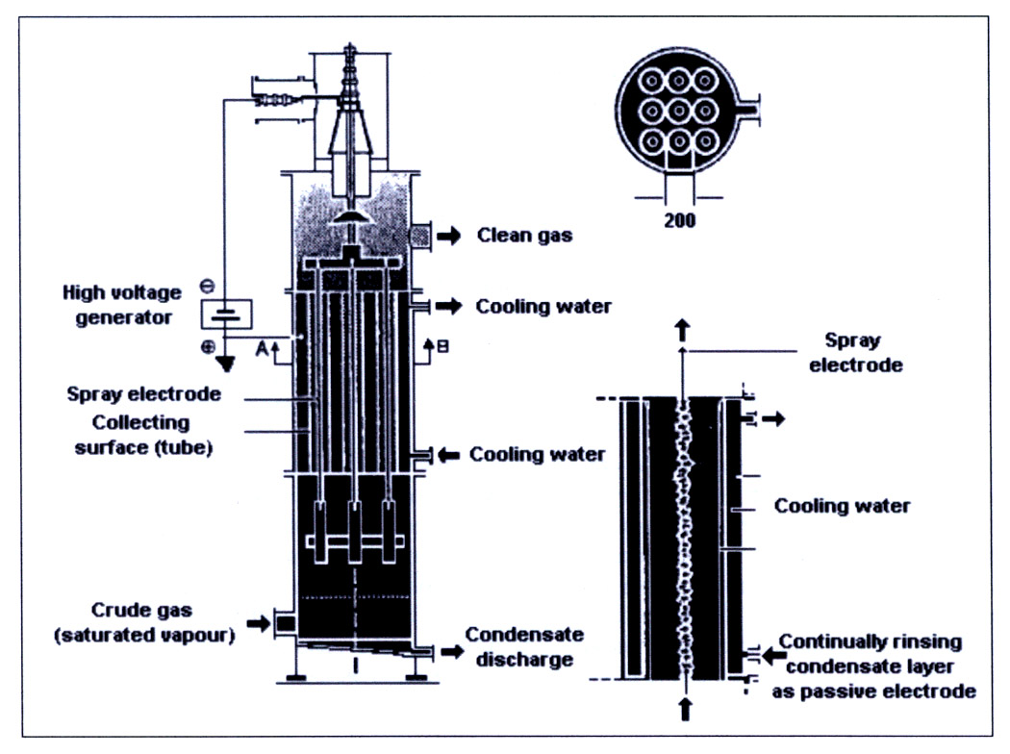
Figure 2. Condensation electrostatic precipitator
Source: European Commission 2005.

            - Fabric filters
Fabric filters are also referred to as baghouses or dust filters (Figure 3). These particulate matter control devices are highly effective in removing chemicals listed in Annex C that may be associated with particles and any vapours that adsorb to the particles in the exhaust gas stream.
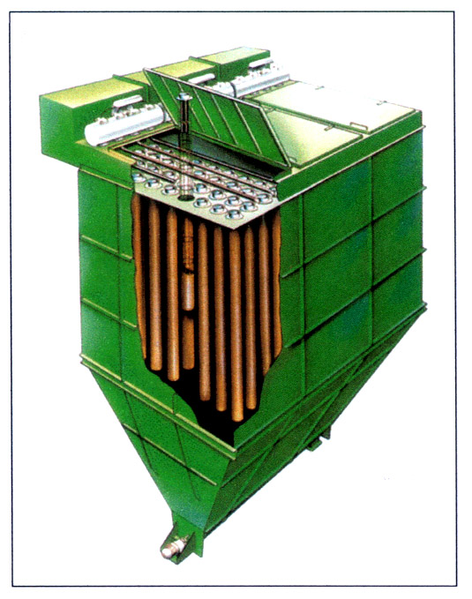
Figure 3. Schematic of a fabric filter
Source: European Commission 2005.

Filters are usually bags of 16 to 20 cm diameter, 10 m long, made from woven fibreglass material or PTFE (see Table 2), and arranged in series. An induction fan forces the combustion gases through the tightly woven fabric, which provides a bed for filter cake formation. The porosity of the fabric and the resulting filter cake allows the bags to act as filter media and retain a broad range of particle sizes down to less than 1 μm in diameter (although at 1 μm capture efficiency begins to decrease). Fabric filters are sensitive to acids; therefore, they are commonly operated in combination with spray dryer adsorption systems for upstream removal of acid gases. Spray drying also serves to cool the inlet gases. Without such cooling, chemicals listed in Annex C may be formed in the fabric filters, similar to the situation with electrostatic precipitators.
Dust removal systems are compared in Table 3.
Table 2. Characteristics of bag filter materials
Fabric | Maximum temperature (°C) | Resistance
Fabric | Maximum temperature (°C) | Acid | Alkali | Physical flexibility
Cotton | 80 | Poor | Good | Very good
Polypropylene | 95 | Excellent | Excellent | Very good
Wool | 100 | Fair | Poor | Very good
Polyester | 135 | Good | Good | Very good
Nylon | 205 | Poor to fair | Excellent | Excellent
PTFE | 235 | Excellent | Excellent | Fair
Polyamide | 260 | Good | Good | Very good
Fibreglass | 260 | Fair to good | Fair to good | Fair
Source: European Commission 2005.

Table 3. Comparison of dust removal systems
Dust removal system | Typical dust emission  concentrations | Advantages | Disadvantages
Cyclone and multicyclone | Cyclones:  200–300 mg/m³  Multicyclones:  100–150 mg/m³ | Robust, relatively simple and reliable  Applied in waste incineration | Only for pre-dedusting  Relatively high energy consumption (compared to electrostatic precipitator)
Electrostatic precipitator, dry | < 5–25 mg/m³ | Relatively low power requirements  Can use gas temperatures in the range of 150°–350 °C but effectively limited to 200 °C by PCDD/PCDF issue (see right) | Formation of PCDD/ PCDF if used in range 450°–200° C
Electrostatic precipitator, wet | < 5-20 mg/m³ | Able to reach low pollutant concentrations | Mainly applied for post-dedusting  Generation of process waste water  Increase of plume visibility
Bag filter | < 5 mg/m³ | Layer of residue acts as an additional filter and as an adsorption reactor | Relatively high energy consumption (compared to electrostatic precipitator)  Sensitive to condensation of water and to corrosion
Source: European Commission 2005.

        - Scrubbing processes
            - Spray dry scrubbing
Spray dry scrubbing, also called spray dryer adsorption or semi-wet scrubbing, removes both acid gas and particulate matter from the post-combustion gases. In a typical spray dryer, hot combustion gases enter a scrubber reactor vessel (Figure 4).

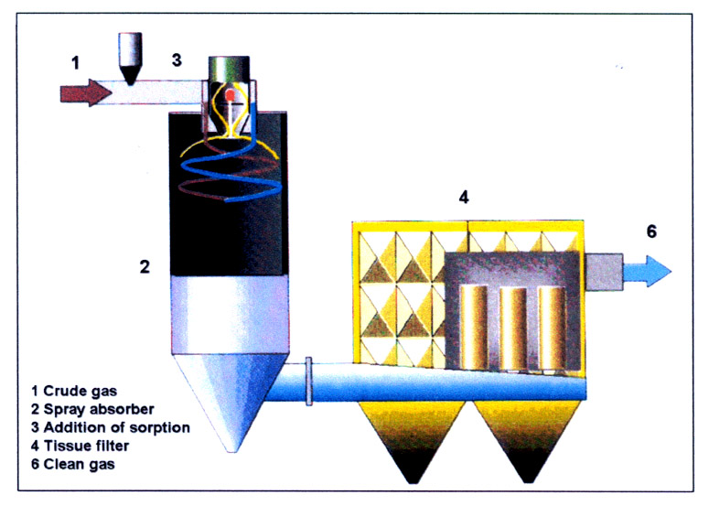
Figure 4. Spray dry scrubbing/adsorption
Source: European Commission 2005.

An atomized hydrated lime slurry (water plus lime) is injected into the reactor at a controlled velocity. The slurry rapidly mixes with the combustion gases within the reactor. The water in the slurry quickly evaporates, and the heat of evaporation causes the combustion gas temperature to rapidly decrease. The neutralizing capacity of hydrated lime can reduce the acid gas constituents of the combustion gas (for example, HCl and SO₂) by as much as 90%. A dry product consisting of particulate matter and hydrated lime either settles to the bottom of the reactor vessel or is captured by the downstream particulate capture device (electrostatic precipitator or fabric filter).
Spray drying technology is used in combination with fabric filters or electrostatic precipitators. In addition to reducing acid gas and particulate matter and control of volatile metals, spray drying reduces inlet temperatures to help minimize formation of chemicals listed in Annex C. PCDD/PCDF formation and release is substantially prevented by quenching combustion gases quickly to a temperature range that is unfavourable to their formation, and by the higher collection efficiency of the resulting particulate matter.
            - Wet scrubbers
Wet scrubbers encompass a number of processes designed for acid gas and dust removal Alternative technologies include jet, rotation, venturi, spray, dry tower and packed tower scrubbers (European Commission 2004, p. 108). Wet scrubbers help reduce formation and release of chemicals listed in Annex C in both vapour and particle forms. In a two-stage scrubber, the first stage removes hydrogen chloride (HCl) through the introduction of water, and the second stage removes sulphur dioxide (SO₂) by addition of caustic or hydrated lime.
In the case of packed tower scrubbers, packing that contains polypropylene embedded with carbon can be used for specific removal of PCDD/PCDF.
            - Fine dust absorber
PCDD/PCDF are separated by fine dust absorbers, which are equipped with a large number of pneumatic two-component jets (water and compressed air). Such high-efficiency absorbers can separate the PCDD/PCDF-covered fine dust through the very fine spray-like dispersal of the absorption solution and the high speed of the water droplets. In addition, the cooling of the exhaust gases and the under cooling in the dust absorber initiate condensation and improve the adsorption of volatile compounds on the dust particles. The absorption solution is treated by waste-water processing. The addition of adsorbents may further improve PCDD/PCDF reduction. With simple scrubbers for the separation of acid exhaust gases appreciable PCDD/PCDF removal is not possible. The achievable emission values of high-efficiency absorbers are in a range of 0.2–0.4 ng I-TEQ/Nm³. This is equal to a separation efficiency of approximately 95% (Hübner et al. 2000).
        - Sorption processes
            - Fixed bed filters
In the fixed bed process precleaned exhaust gases are conducted at temperatures of 110°–150 °C through an activated coke bed. Necessary devices include fresh adsorbent supply, the fixed bed reactor and the spent adsorbent system. The activated coke bed separates residual dust, aerosols and gaseous pollutants. It is moved cross-current and countercurrent in order to prevent blockage of the bed through, for example, residual dust. Usually, the PCDD/PCDF-covered coke is disposed off through internal combustion. Organic pollutants are destroyed to a large extent. Inorganic pollutants are released via slags or separated in the exhaust gas fine cleaning again. The fixed bed process achieves PCDD/PCDF reductions of 99.9%. Compliance with a performance standard of 0.1 ng I-TEQ/Nm³ is state-of-the-art (Hübner et al. 2000; Hartenstein 2003).
            - Flow injection process
In order to enhance the separation efficiency of fabric filters, adsorbents with high PCDD/PCDF take-up capacities are injected into the exhaust gas stream. In general, activated coal or hearth-type coke are used as adsorbents together with lime hydrate. The separation is carried out in a fabric filter located at the end of the process, where adsorbents and dust are separated and a filter layer is formed. The appropriate disposal of the PCDD/PCDF-containing filter dust has to be assured. Conventional operation temperatures range from 135° to 200° C.
With the flow injection process, filtration efficiencies of 99% are achieved. The PCDD/PCDF removal efficiency depends on the quality of the adsorbent injection, the effectiveness of the adsorbent-flue gas mixing system, the type of particulate filter and the operation of the system. Another critical parameter is the mass flow rate of the injected adsorbent. For applying this technology most effectively a baghouse should be used. Compliance with a performance standard of 0.1 ng I-TEQ/Nm³ is state-of-the-art (Hübner et al. 2000; Hartenstein 2003).
            - Entrained flow reactor
For this technology the same adsorbents are applied as used for the adsorbent injection process. However, the adsorbent is usually applied in a mixture with hydrated lime or other inert materials such as limestone, quicklime or sodium bicarbonate. Upstream of the entrained flow reactor for flue gas polishing, a conventional flue gas cleaning system is required for removing the bulk of the fly ash and the acid gases. Necessary devices include fresh adsorbent supply, fabric filter, recirculation system and spent adsorbent system. Conventional operation temperatures range from 110° to 150° C. Compliance with a performance standard of 0.1 ng I-TEQ/Nm³ is state-of-the-art (Hartenstein 2003).
            - Dry Absorption (in Resins)
A new flue gas cleaning technology has been developed that combines adsorption and absorption of PCDD/PCDF into plastic structures containing dispersed carbon particles. In this new material, the PCDD/PCDF are first adsorbed in the polymer matrix and then they diffuse to the surface of the carbon particles where they are irreversibly absorbed. The most common application of AdioxTM is tower packings employed in gas cleaning systems. Until now, more than 30 full-scale incineration lines with flow gases ranging from 5,000 to 100,000 Nm³/h are installed in wet flue gas cleaning systems. The removal efficiency depends on the amount of installed material. The technology can be applied as the main PCDD/PCDF cleaning system or to increase the safety margins or to reduce the memory effect in wet scrubbers. If Adiox is employed in dry adsorbers, the removal efficiency per installed amount is higher (Andersson 2005).

        - Catalytic oxidation of PCDD/PCDF
            - Selective catalytic reduction
Catalytic oxidation processes, which are normally used for reducing nitrogen oxide emissions, are applied for PCDD/PCDF destruction as well. Therefore, effective de-dusting (e.g. emission values of particulate matter of below 5 mg/m³ is a requirement of achieving low overall emissions of POPs. For the removal of PCDD/PCDF only (for example, with the DeDiox process), ammonia injection is not necessary. In this case operation temperatures range from 130° to 350° C.
The main advantages of this process are an easy operation and no residues apart from very little spent catalyst. Therefore, catalytic oxidation does not cause disposal problems.
Decomposition reaction for Cl₄DD: C₁₂ H₄ Cl₄ O₂ + 11 O₂ → 12 CO₂ + 4 HCl
In general, the installations are operated in clean gas circuits, i.e., dust and heavy metals are separated before the catalyst in order to prevent rapid wear and deactivation of the catalysts through catalyst poisons.
With catalytic oxidation, only the PCDD/PCDF fraction in the gas phase can be captured. Nevertheless, emission reductions of 95 to 99% can be achieved. PCDD/PCDF reduction rate depends on the installed catalyst volume, the reaction temperature and the space velocity of the flue gas through the catalyst. PCDD/PCDF testing showed emission values lower than 0.01 ng I-TEQ/Nm³ (dry basis, 11% O₂).
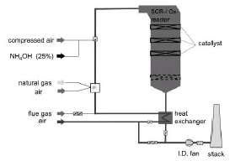
In the selective catalytic reduction process for combined removal of PCDD/PCDF and NO_{x} an air-ammonia mix is injected into the flue gas stream and passed over a mesh catalyst (Figure 5). The ammonia and NO_{x} react to form water and N₂ (European Commission 2004; Hübner et al. 2000; Hartenstein 2003).
Figure 5. High-temperature selective catalytic reduction reactor for simultaneous NO_{x} and PCDD/PCDF removal

Source: Hartenstein 2003.

            - Catalytic bag filters
Catalytic bag filters with PTFE membrane enable dust concentrations in cleaned flue gases of about 1–2 mg/Nm³. Currently applications are known in waste incineration, crematoria, metal industries and cement plants. Filter bags that are impregnated with a catalyst, or contain a powdered catalyst directly mixed in fibre production, have been used to reduce PCDD/PCDF emissions. This type of filter bag is generally used without the addition of activated carbon so that the PCDD/PCDF can be destroyed on the catalyst rather than absorbed in the carbon and discharged as solid residues. They operate at temperatures between 180° and 250° C.
The REMEDIA Catalytic Filter System incorporates micro-porous PTFE fiber with the catalyst particles built into the fiber structure. In this process, PTFE particles are mixed with the catalyst and processed to produce fibers. A micro-porous ePTFE membrane is laminated to the ePTFE/catalyst micro-porous fibers to produce the filtration media. This material is then sewn into filter bags, which can be installed in a baghouse. Applications at German and Japanese crematories gave emissions below 0.1 ng I-TEQ/Nm3 (Xu et al. 2003).

- Treatment of flue gas treatment residues
Current practices for the treatment and disposal of flue gas treatment residues include reuse in the process from which they were derived, disposal to landfill, stabilization and subsequent disposal, vitrification, incorporation into road-making materials, valorization in salt or coal mines, and catalytic or thermal treatment.
According to the Basel Convention, annex I, wastes, including fly ashes, having as constituents PCDD or PCDF are classified as hazardous waste.
  - Solidification of flue gas treatment residues
The main purpose of solidification is to produce a material with physical and mechanical properties that promote a reduction in contaminant release from the residue matrix. An addition of cement, for example, generally decreases hydraulic conductivity and porosity of the residue, and, on the other hand, increases durability, strength and volume.
Solidification methods commonly make use of several, mostly inorganic, binder reagents: cement, lime and other pozzolanic materials such as coal fly ash, blast furnace bottom ash or cement kiln dust, although some organic binders such as bitumen/asphalt or paraffin and polyethylene can also be used. Combinations of binders and various types of proprietary or non-proprietary additives are used as well. By far the most prevalent solidification technique is cement stabilization.
  - Thermal treatment of flue gas treatment residues
Thermal treatment can be grouped into three categories: vitrification, melting and sintering. The differences between these processes are chiefly related to the characteristics and properties of the final product:
Vitrification is a process whereby residues are treated at high temperature (currently 1,300° to 1,500° C) and then quickly quenched (with air or water) to obtain an amorphous glassy matrix. After cooling down, the melt forms a single-phase product called a vitrificate. The vitrificate can be a glass-like or stone-like product, depending on the melt composition. Additives are sometimes (but not usually) added to the residues to favour the formation of the glassy matrix.
Melting is similar to vitrifying, but the quenching step is controlled to allow crystallization of the melt as much as possible. It results in a multiphase product. Temperatures and the possible separations of specific metal phases are similar to those used in vitrifying. It is also possible to add specific additives to favour the crystallization of the matrix.
Sintering involves the heating of residues to a level where bonding of particles occurs and the chemical phases in the residues reconfigure. This leads to a denser product with less porosity and a higher strength than the original product. Typical temperatures are around 900° C. When municipal solid waste is incinerated some level of sintering will typically take place in the incineration furnace. This is especially the case if a rotary kiln is used as part of the incineration process.
Regardless of the actual process, the thermal treatment of residues in most cases results in a more homogeneous, denser product with improved leaching properties. The energy requirements of stand-alone treatments of this type are generally very high.
  - Extraction and separation of flue gas treatment residues
Treatment options using extraction and separation processes can, in principle, cover all types of processes extracting specific components from the residues. However, most emphasis has been put on processes involving an extraction of heavy metals and salts with acid.
  - Chemical stabilisation of flue gas treatment residues
The main concept of chemical stabilization is to bind the heavy metals in more insoluble forms than they are at present in the original untreated residues. These stabilization methods make use of both the precipitation of metals in new minerals as well as the binding of metals to minerals by sorption. This process includes the solubilization of the heavy metals in the residues and a subsequent precipitation in, or sorption to, new minerals.
Several of the stabilization methods incorporate an initial washing step whereby a major part of soluble salts and to some extent metals are extracted before chemical binding of the remaining metals. These methods are completed by dewatering the stabilized product.

References
Andersson S. 2005. “PCDD/F Removal from Gases using a Dry Adiox Absorber.” Organohalogen Compd. 67, 2226-2229.
European Commission. 2005. Reference Document on the Best Available Techniques for Waste Incineration. BAT Reference Document (BREF), Final Draft, July 2005. European IPPC Bureau, Seville, Spain. eippcb.jrc.es/pages/FActivities.htm.
Hartenstein H.U. 2003. “Dioxin and Furan Reduction Technologies for Combustion and Industrial Thermal Process Facilities.” In: The Handbook of Environmental Chemistry Vol. 3, Part O: Persistent Organic Pollutants (ed. H. Fiedler). Springer-Verlag, Berlin and Heidelberg.
Hübner C., Boos R., Bohlmann J., Burtscher K. and Wiesenberger H. 2000. State-of-the-Art Measures for Dioxin Reduction in Austria. Vienna. www.umweltbundesamt.at/fileadmin/site/publikationen/M116.pdf
Xu Z., Wedman, R. Bucher, O. Petzoldt T. Sasamoto, and M. Wilken 2003. “ Removal and Destruction of PCDD/F from Crematories by REMEDIA TM Catalytic Filter System.” Organohalogen Compd. 63, 216-219.

    - Training of decision makers and technical personnel
The importance of technical assistance, in particular training, as a need to strengthen the national capabilities of developing countries (in particular the least developed), and countries with economies in transition, is recognized in the preambular paragraphs of the Stockholm Convention, and Article 12 states: “Parties recognize that rendering of timely and appropriate technical assistance in response to requests from developing country Parties and Parties with economies in transition is essential to the successful implementation of this Convention.”
In this regard capacity-building technical assistance, in particular training in available environmental methodologies, practices and tools, with specific reference to the particular needs of a Party, may give a better understanding of procedures for conducting, on a sustained basis, daily operational practices and preventive maintenance of the best available techniques and best environmental practices being introduced as part of the Party’s national implementation plan. It is of utmost importance that capacity-building technical assistance, in particular training, should be provided at both managerial and technical or operating levels in public and private sector organizations involved in the implementation of the guidelines for best available techniques and best environmental practices. Taking into consideration the complexity of many best available techniques and the required holistic and preventive approach for introducing best environmental practices, life cycle management, in addition to relevant health and safety issues, should be given priority consideration in capacity-building, with a risk prevention and reduction approach.

    - Testing, monitoring and reporting
1. Testing and monitoring
Monitoring of releases of chemicals listed in Annex C of the Stockholm Convention is critical to achieving the goals of the Convention. However, many developing countries and countries with economies in transition do not have the necessary capacity in terms of costs, technical expertise and laboratories and, in some cases, the economic returns for facilities may not be sufficient to cover all costs associated with monitoring. Consequently, it is necessary to establish and strengthen regional, subregional and national technical capacity and expertise, including laboratories. This enhanced capacity may also promote monitoring at specified intervals for existing sources.
Proposals for new facilities or proposals to significantly modify existing facilities should, as part of best available techniques and best environmental practices, include plans for the evaluation of compliance with the target values for releases of chemicals listed in Annex C in stack gases and other outputs that are given in this guidance document. Accordingly, as part of ongoing operation, these facilities should demonstrate, through monitoring at specified intervals, as appropriate, that the performance levels continue to be achieved.,
Validated, standardized methods of sampling and analysis are available for polychlorinated dibenzo-p-dioxins (PCDD) and polychlorinated dibenzofurans (PCDF) but not yet for all chemicals listed in Annex C. The methods for sampling and monitoring for PCB and HCB must be developed and validated. Methods for sampling stack gases include those with sampling periods of 4 to 8 hours as well as those that are quasi-continuous. Most if not all regulatory regimes for PCDD/PCDF are currently based on toxic equivalents (TEQ).,
Four bioassay methods, three reporter gene bioassay methods and an enzyme imunoassay method, have been approved in Japan for measuring dioxins in emission gas, dust and cinders from waste incinerators. The methods provide a less costly alternative to high-resolution gas chromatography/mass spectrometry and are approved for measuring emissions from incinerators with a capacity less than 2 tons/hour (emission standards for new facilites: 5 ng WHO-TEQ/Nm³) and dust and cinders from all waste incinerators (treatment standard 3 ng WHO-TEQ/g).
Guidelines for appropriate monitoring programmes are also necessary. In that regard, the United Nations Environment Programme (UNEP) has developed guidance for prioritizing measurements and minimizing the number of measurements for impact assessment. The European Commission has prepared a reference document on the general principles of monitoring; and some companies and industry associations have agreed monitoring requirements. Model legislation and regulations will also facilitate the establishment and implementation of programmes to monitor releases of chemicals listed in Annex C, including such approaches as bioassay monitoring. One of the less costly bioassay methods has been validated but is in widespread use for screening purposes only.
- Priority sources include those listed in Part II of Annex C of the Stockholm Convention.

Table 4. Methods for determination of PCDD/PCDF
Method | Substances analyzed | Analytical principle | Reference
EN 1948 | PCDD/PCDF | HRGC/HRMS | European Committee for Standardization
US EPA Method 23 | PCDD/PCDF | HRGC/HRMS | U.S. Environmental Protection Agency
Japanese Industrial Standard K 0311 | PCDD/PCDF, dioxin-like PCBs | HRGC/HRMS | Japanese Industrial Standards Committee
CALUX Assay | Dioxins | Reporter gene assay | Xenbiotic Detection Systems International
P450 Human Reporter Gene System | Dioxins | Reporter gene assay | Columbia Analytical Services
AhR luciferase assay | Dioxins | Reporter gene assay | Sumitomo Chemical Co, Ltd
Dio-Quicker | Dioxins | Enzyme immunoassay | TAKUMA Co., Ltd

2. Reporting

Reporting of releases and other relevant information is a key part of meeting Party obligations under Article 9 (Information exchange), Article 10 (Public information, awareness and education), Article 11 (Research, development, and monitoring). Parties seeking to employ best environmental practices for Annex C sources should include measures described in these Articles, including:

- Mechanisms such as pollutant release and transfer registers to collect and disseminate comprehensive and chemically specific information on production and releases of chemicals listed in Annex A, B or C together with their sources.
- Public participation in the regulation of sources of chemicals listed in Annex C
- Public availability of monitoring data collected from Sources in Annex C (taking into account paragraph 5 of Article 9)
- Making their results of research, development and monitoring activities accessible to the public on a timely and regular basis (Article 11 2 (e)).

Full provision of relevant information can encourage and facilitate public participation.

World Commission on Environment and Development. 1987. www.un.org/documents/ga/res/42/ares42-187.htm.
UNEP (United Nations Environment Programme). 1994. Oslo Symposium: Sustainable Consumption. Oslo, Norway, January 1994. www.iisd.org/susprod/principles.htm.
UNEP (United Nations Environment Programme). 2002. Environmental Impact Assessment Training Resource Manual. Page 558. www.iaia.org/Non_Members/EIA/ManualContents/Vol1_EIA_Manual.pdf.
UNEP (United Nations Environment Programme). 1992. Rio Declaration on Environment and Development. Principle 15. Rio de Janeiro, Brazil, 1992. www.unep.org/Documents/Default.asp?DocumentID=78&ArticleID=1163.
Preamble to Stockholm Convention and Principle 16 of the Rio Declaration on Environment and Development.
Environment Canada. 1995. Pollution Prevention – A Federal Strategy for Action. www.ec.gc.ca/cppic/aboutp2/en/glossary.cfm.
European Commission. 1996. Integrated Pollution Prevention and Control Directive. 96/61/EC. europa.eu.int/smartapi/cgi/sga_doc?smartapi!celexapi!prod!CELEXnumdoc&lg=EN&numdoc=31996L0061&model=guichet.
UNEPTIE. www.uneptie.org/pc/cp/understanding_cp/home.htm.
European Environment Agency. glossary.eea.eu.int/EEAGlossary.
UNEPTIE. www.uneptie.org/pc/sustain/reports/lcini/lc-initiative-barcelona-workshop.pdf.
Environment Canada. 1999. Canadian Environmental Protection Act, 1999. Section 65. www.ec.gc.ca/CEPARegistry/the_act/.
PCDD/PCDF may also be introduced as contaminants in raw materials or wastes and may therefore appear in processes in which PCDD/PCDF formation does not occur.
Combustion controls and other factors which affect formation and release of chemicals listed in Annex C of the Stockholm Convention upstream of the flue gases are described in the sector-specific guidance notes (sections V and VI).
1 ng (nanogram) = 1 × 10⁻¹² kilogram (1× 10⁻¹² kilogram or 1 × 10⁻⁹ gram); Nm³ = normal cubic metre, dry gas volume measured at 0 °C and 101.3 kPa. For information on reporting PCDD/PCDF results see section I.C, subsection 3 of the present guidelines.
1 μm (micrometre) = 1×10⁻⁶ metre.
The subparagraphs in paragraph 2 are cited from European Commission 2005, chapter 2.7.3.
Determination of the mass concentration of chemicals listed in Annex C in releases from a given source should follow nationally or internationally recognized standard methods of sampling, analysis and evaluation of compliance.
In most cases, target values currently exist only for PCDD/PCDF.
To determine TEQ concentrations, each of the 17 PCDD/PCDF congeners that are of greatest toxicological concern are quantified using a high-resolution gas chromatograph/mass spectrometer.

